Eclipse +ThinkPHP+git 集成开发运行环境配置

概述
本文档旨在对基于Eclipse和ThinkPHP的集成开发环境配置以及Eclipse上git的使用进行说明。
版本说明：
Wampserver：WampServer 64 bits (x64) 3.0.6
Eclipse PHP + Git: eclipse-php-oxygen-R-win32-x86_64
ThinkPHP: ThinkPHP5.0.11完整版

Wampserver安装
http://jingyan.baidu.com/article/9f7e7ec0bdafb06f281554c0.html
安装之后有个 www目录。里面可以放html文件和php文件，是服务器的根目录。开发项目工程就存放在这个目录进行调试运行。

Eclipse php环境配置
http://blog.csdn.net/yueyemoyan/article/details/54965128?locationNum=6&fps=1

Eclipse Git环境配置和使用
http://blog.csdn.net/s164828378/article/details/51723698

ThinkPHP开发调试实例
Step1: Create Demo folder under C:\wamp\www where Wampserver is installed.
Step2: Unzip thinkphp_5.0.11_with_extend and copy all contents under this folder to Demo
Step3: Create PHP project with Eclipse named Demo via: File -> New -> Project -> PHP Project
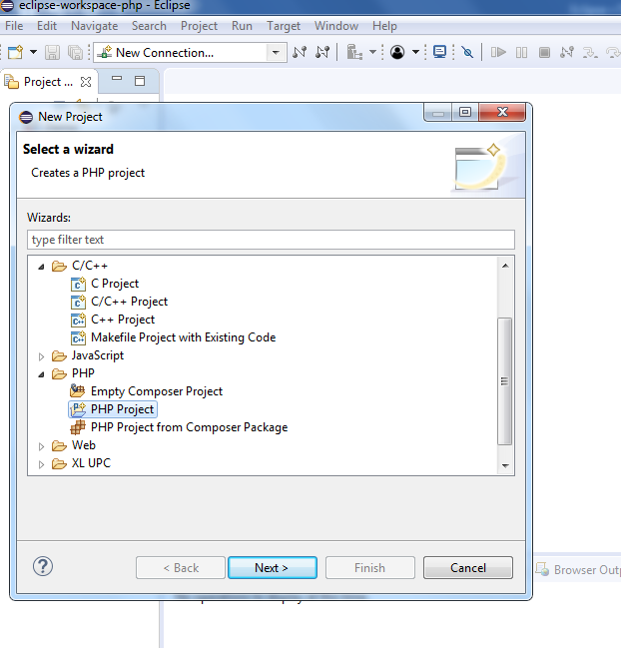
Click Next to next page:
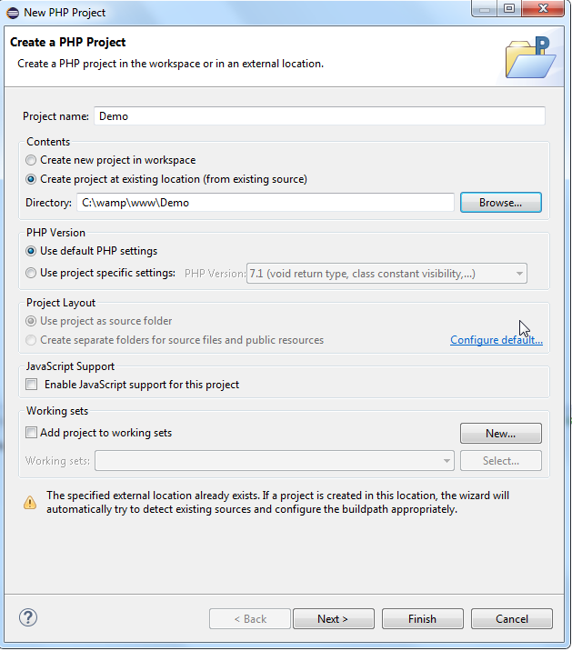

Specify Demo as project name and select Create project at existing location (from existing source), click Next -> Next -> Finish. A demo project will then be created as below:

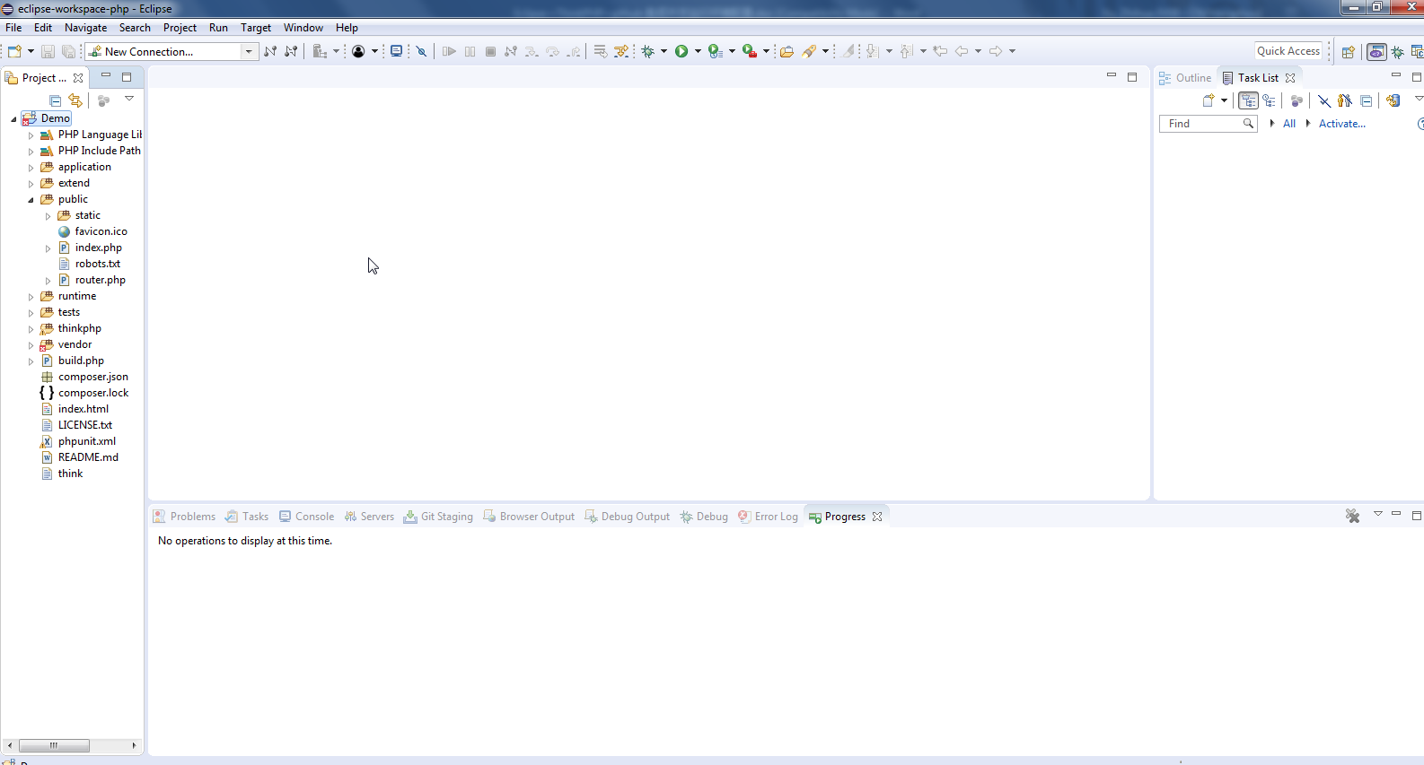

Step4: Running
Open index.php under public, click Run -> Run As -> 3 PHP Web Application
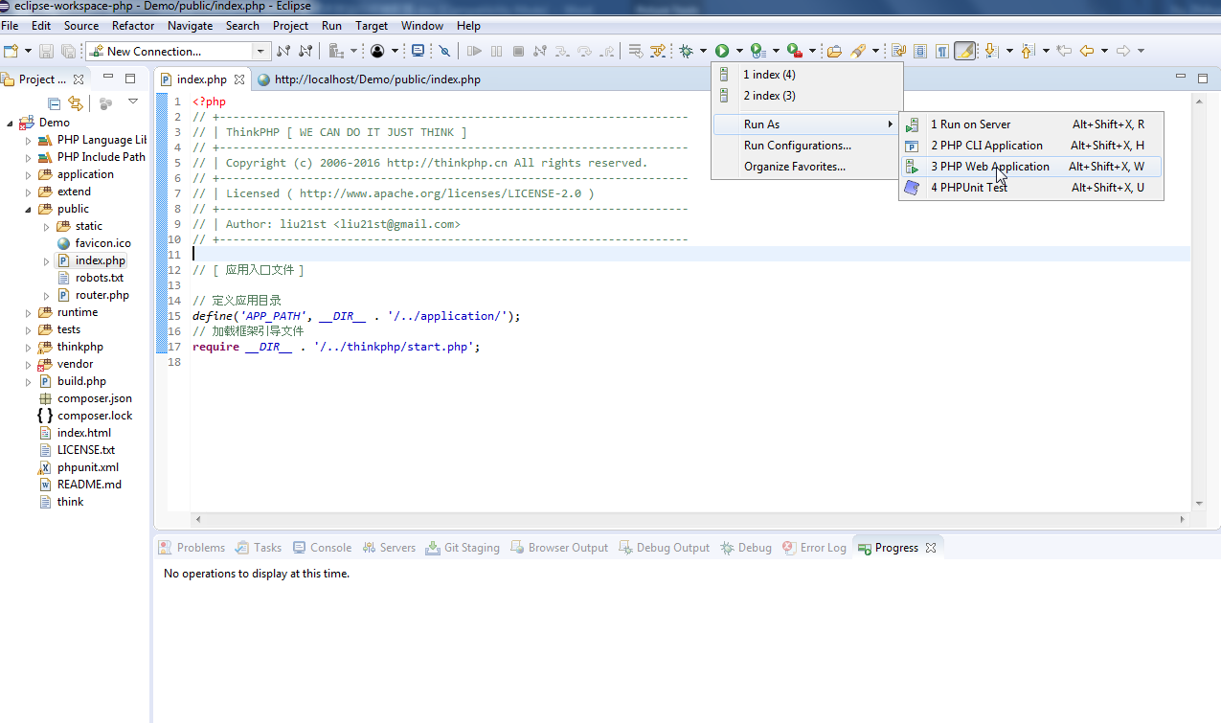
The result will be shown as below:
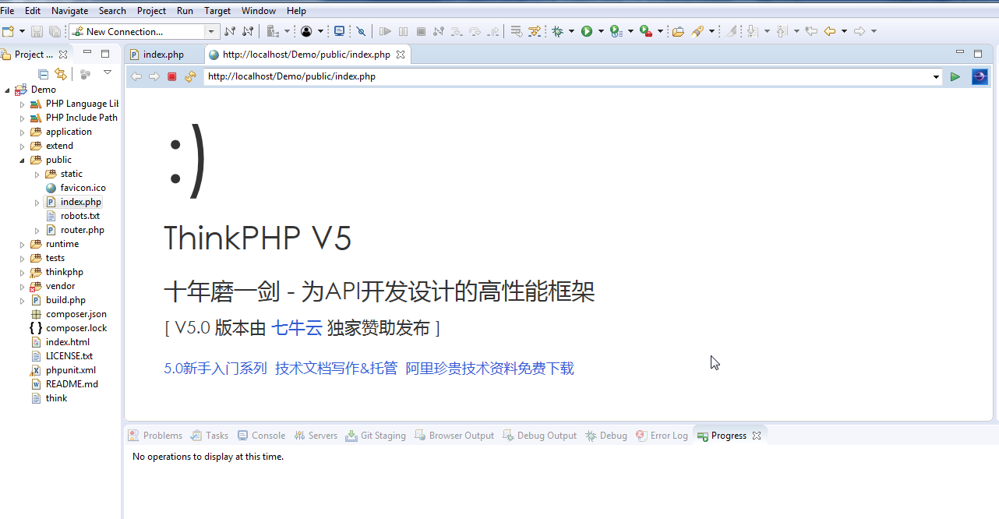

Step5: Debugging
Click -> Debug Configuration
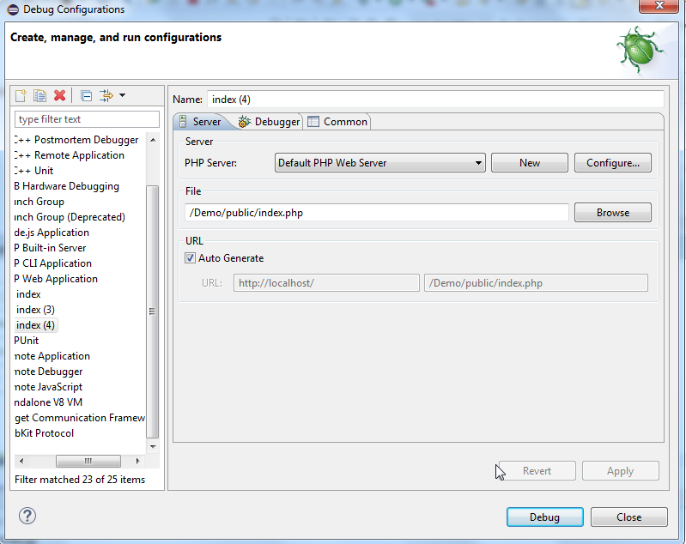

Click Configuration on the Debug Configuration diaglog:
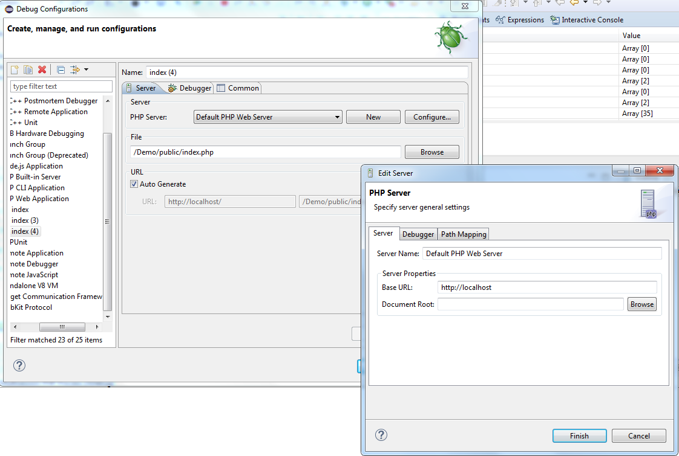

Click Debugger tab and select XDebug from the Debugger list, click Finish to close the dialogs
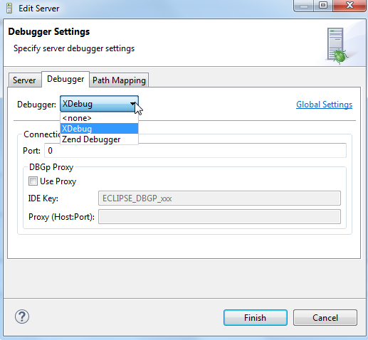
Click -> Debug As -> 3 PHP Web Application

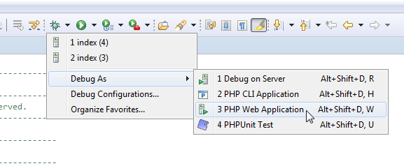
The Debugging window will display as below:

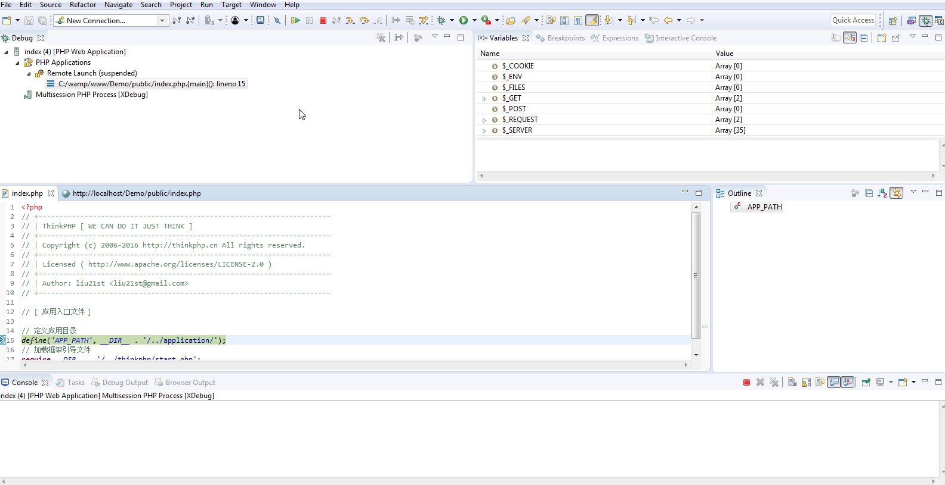

Press F5 to debug step by step.
Click to resume, the result will display as below:

